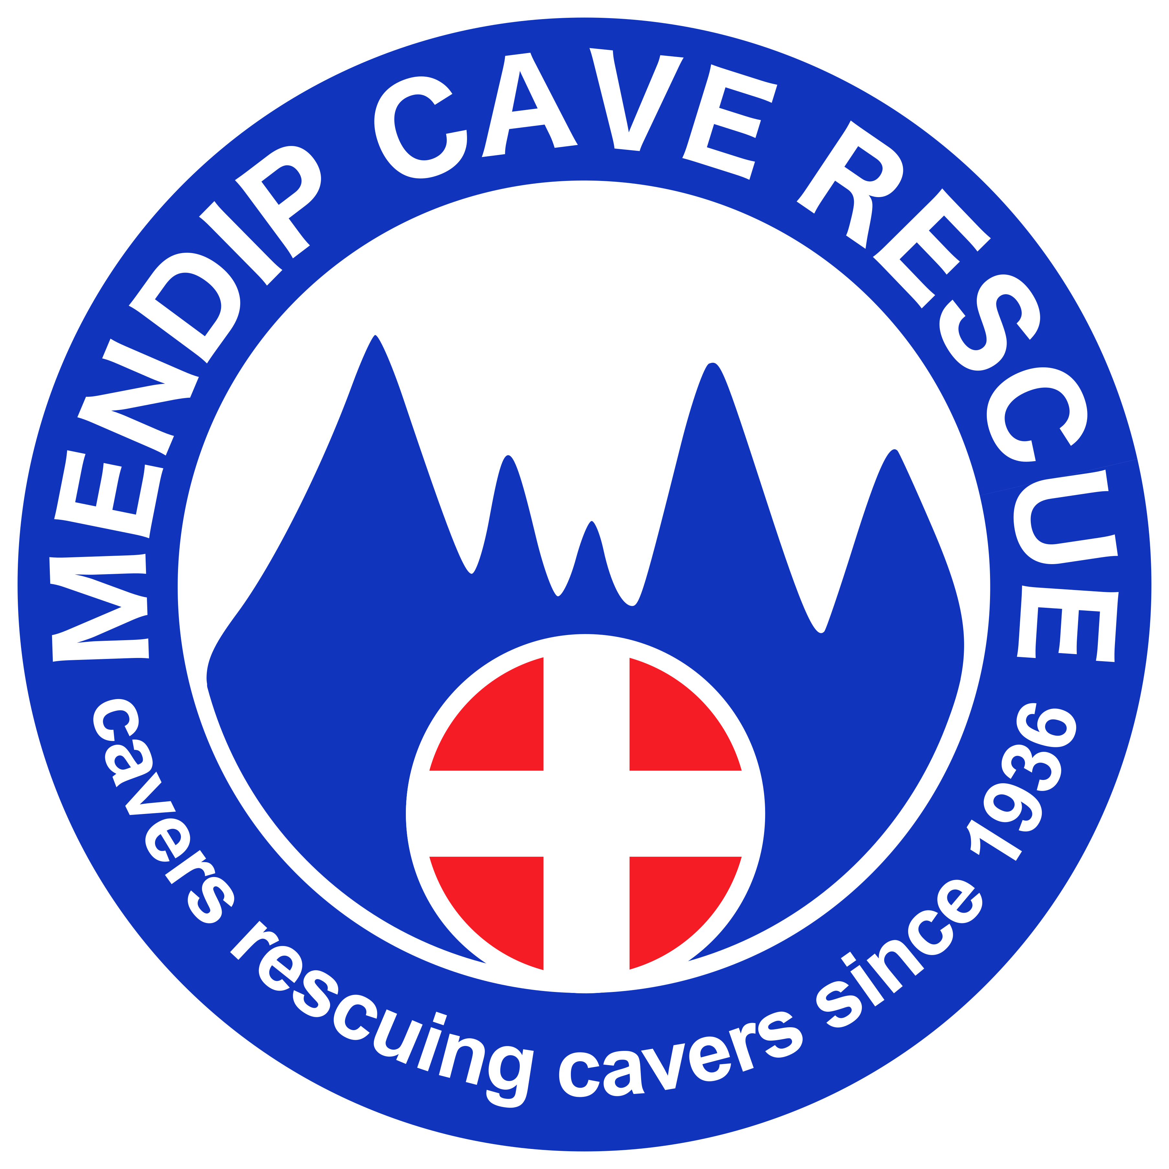 | Mendip Cave Rescue  Application for Associate Membership

Introduction

Thank you for showing interest in becoming an Associate Member of Mendip Cave Rescue.

As a volunteer team member, you have a vital role to play in assisting MCR to provide the underground search and rescue service that cavers, other emergency services and the general public have come to rely on. MCR covers underground rescues in all areas of Somerset, Dorset and most of Wiltshire so knowledge of the stone mines of Wiltshire, the caves of Portland and the outlying areas of Somerset are just as important as caves on Mendip.

The Associate Member category is for individuals with desirable skills who cannot commit to MCR's training requirements for full members. Associate membership is also open to ex-Members / ex-Wardens who wish to offer a supporting role, or help out in some way, but do not wish to take on any operational responsibilities. Associate members do not have voting rights within MCR, and can only attend training sessions and meetings at the discretion of the Officers.

Anyone wishing to join MCR as an Associate Member must meet the person specification detailed below, and be “sponsored” by a Full Member of MCR. Associate members will be expected to adhere to a code of conduct and meet limited training requirements (these will be determined on an individual basis and will be dependant on your likely role in a rescue). Associate members will also be expected to be self-sufficient underground and have their own suitable personal caving equipment including lights, SRT kit etc.

To apply to join MCR as an Associate Member, we ask you to complete the following membership form and submit this to the Membership Secretary. Your sponsor must also submit a Sponsors Form to support your application. Your application will be discussed at the next general meeting (held quarterly). If your application is successful, we will then discuss training requirements with you. If terms are mutually agreeable, we will welcome you to the team for future callouts.

If any of the information on this form changes, please let us know as soon as possible, as we have a responsibility to ensure that all information is kept up to date.

Before completing the membership form, please take the time to read the Code of Conduct and Data Protection Policy documents that are available on our website. If you have any queries, please contact the membership secretary.

We look forward to welcoming you to Mendip Cave Rescue.

Person Specification

Associate membership of MCR is open to cavers who are over 18 years old and meet the following criteria:

- At least two years of caving experience
- Active & available in MCR's area of operation for the foreseeable future
- Current member of the British Caving Association, or affiliated caving club
- Ability & desire to work in a team
- Will give service freely & voluntarily, with no vested personal interest
- Able to bring specific specialist knowledge or skills required by MCR, for example rescue diver, current holder of an explosives license, or expert knowledge, or warden, of complex, very tight or access-restricted caves
- Available for training. Training requirements will depend on their likely role in a rescue and will be determined on an individual basis

For underground roles, the following additional criteria apply:
- Fit enough to tackle a variety of caves in the region covered by MCR
- Vertical caving skills, including:
  - safe approach to pitches
  - safe belaying techniques
  - able to tie a variety of knots

Personal Details

Full name
Date of birth
Home address
(including postcode)
Home phone number
Mobile phone number
Email address
Primary caving club
Work phone number
(if available from work)

Emergency Contact Details

Name of next of kin
Home address
(including postcode)
Home phone number
Mobile phone number

Skills & Experience

Brief details of caving experience
(for example, typical number of trips per year, type of trips, experience of harder trips, etc)
Do you hold a current First Aid qualification?
(please give details and dates)
Please give details of any Mendip caves you are a warden for
Please give details of any sites you have a good knowledge of in the region covered by MCR
Are you a current or past member of any other cave rescue team
(please give details of other teams)
Are you a diving member of the CDG?
Do you hold a current explosives licence?
Other relevant skills or qualifications
Do you have any medical conditions that may limit rescue activities?
Name of MCR sponsor

Application

I meet the person specification (as listed on page 2) | Y / N
I can commit to the MCR Code of Conduct | Y / N
I am not applying to join MCR for any vest personal or commercial gain | Y / N
I have read and understood how MCR will use my personal data and consent to my data being used accordingly | Y / N
I have asked my sponsor to complete the Sponsors Form for my application | Y / N
I confirm that all the information I have provided is accurate | Y / N
Signature: | Date:

membership@mendipcaverescue.org https://www.mendipcaverescue.org

