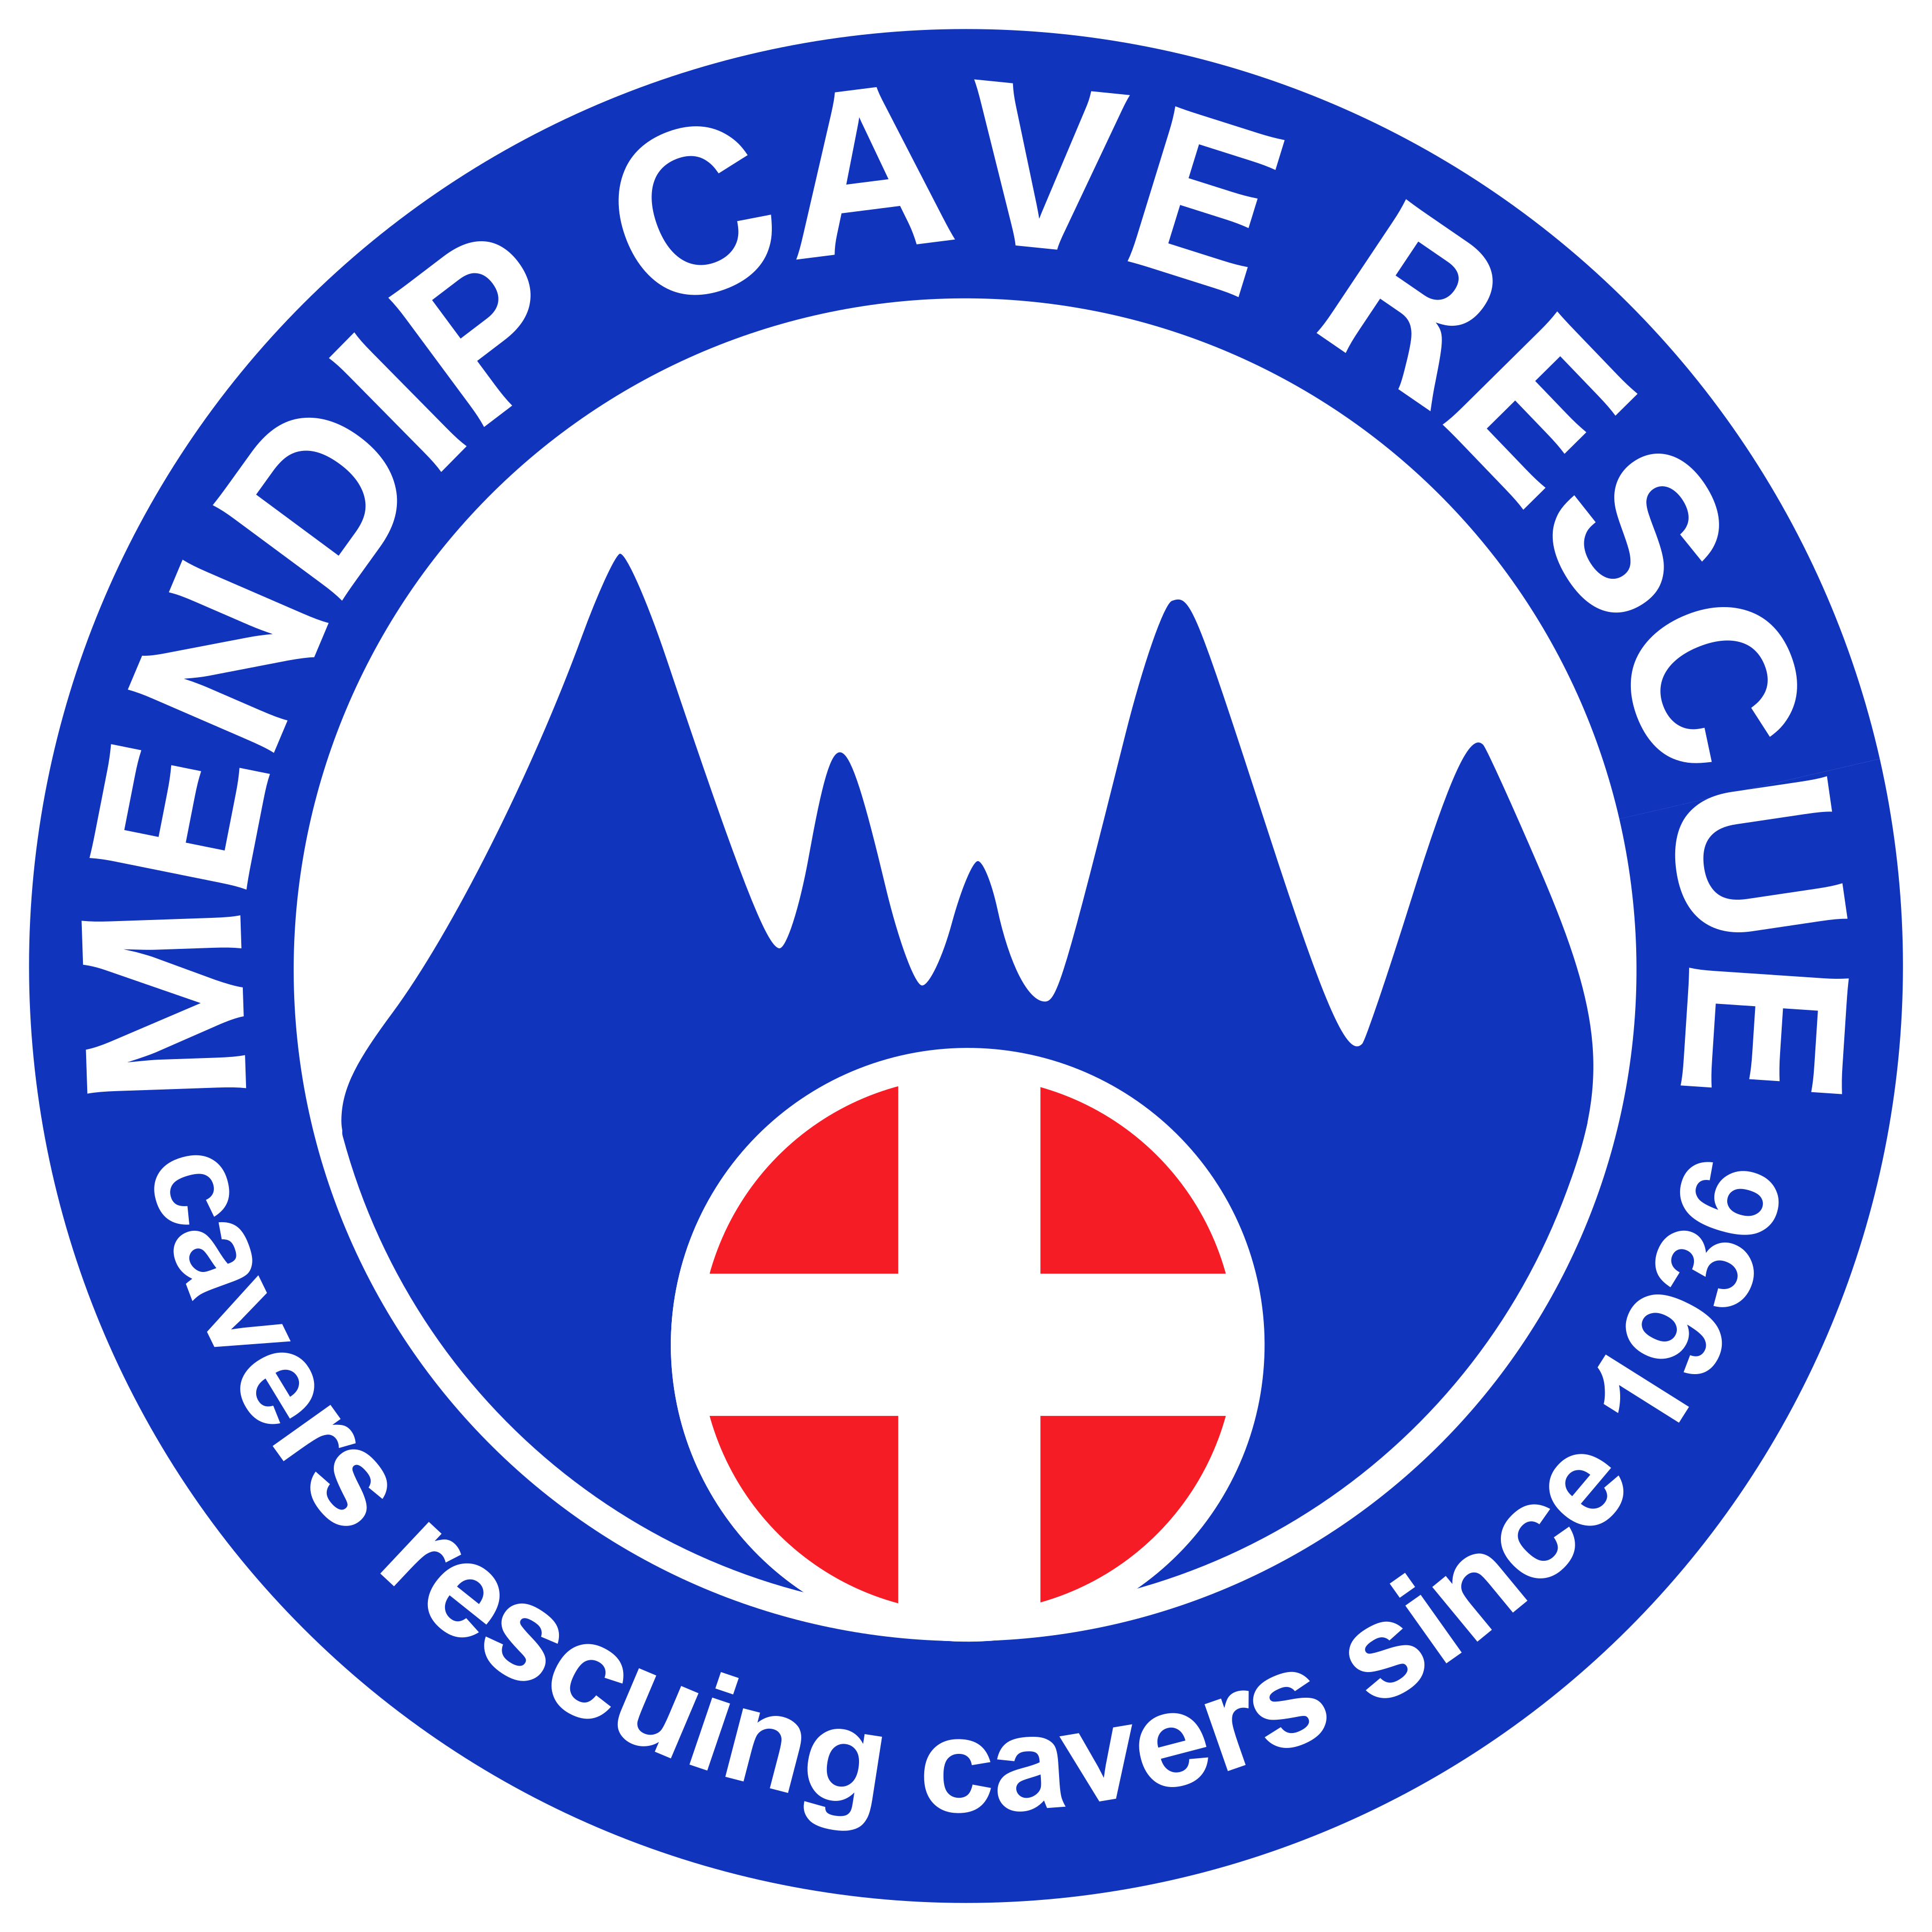 | Mendip Cave Rescue  Application for Core Membership

Introduction

Thank you for showing interest in becoming a Core Member of Mendip Cave Rescue.

As a volunteer team member, you have a vital role to play in assisting MCR to provide the underground search and rescue service that cavers, other emergency services and the general public have come to rely on. MCR covers underground rescues in all areas of Somerset, Dorset and most of Wiltshire so knowledge of the stone mines of Wiltshire, the caves of Portland and the outlying areas of Somerset are just as important as caves on Mendip. As a Core Member, you will have full voting rights within MCR and can stand for Officer positions if desired.

Anyone wishing to join MCR as a Core Member must meet the person specification detailed below, and be “sponsored” by a Full Member of MCR. Members are expected to meet MCR’s training requirements and adhere to a code of conduct. Members must also be self-sufficient underground and have their own suitable personal caving equipment including lights, SRT kit etc.

To apply to join MCR as a Core Member, we ask you to complete the following membership form and submit this to the Membership Secretary. Your sponsor must also submit a Sponsors Form to support your application. Your application will be discussed at the next general meeting (held quarterly). Successful applicants will spend a minimum of 12 months (up to a maximum of 24 months) as a Provisional Member, during which time you'll be assigned a mentor (usually your sponsor) to guide you through the induction process, help facilitate any training required and introduce you to other MCR members.

If any of the information on this form changes, please let us know as soon as possible, as we have a responsibility to ensure that all information is kept up to date. Please also supply a photograph of yourself, suitable for use on a members identification card (for example a passport photo)

Before completing the membership form, please take the time to read the Code of Conduct and Data Protection Policy documents that are available on our website. If you have any queries, please contact the membership secretary.

We look forward to welcoming you to Mendip Cave Rescue.

Mendip Cave Rescue Group System

Mendip Cave Rescue has developed a system of “Operational Groups”, where specialist skills can be developed and training given. New members will be invited to join one (or more) of these groups, based on operational need and the preference of the member. The operational groups are:
- Operations Group. Responsible for the overall implementation of the rescue effort underground. Training will include general rescue exercises including passage negotiation skills, passage stability / modification, air quality, stuck caver, and water diversion.
- Command & Control Group. A largely surface-based group, responsible for the coordination of rescue operations and liaising with other emergency services present at the scene. This group will ensure that a command structure is in place during rescues, establishing communications where necessary.
- Medical Group. Open to suitably qualified healthcare professionals or cavers wanting to undergo specialist “MREW Casualty Care” training. Training is delivered by a doctor and paramedic, and upon successful completion of the course you will be able to provide treatment for a wide range of conditions.
- Rigging Group. Responsible for developing MCR's rigging expertise, establishing standards, and sharing knowledge with other members of MCR.
- Diving Group, open to CDG divers. Divers will also be expected to join one of the four principal groups. This is to ensure that divers can operate independently as a cohesive unit beyond a sump, and promotes better integration of divers into the team.
- Stone Mines Group, open to members with expert knowledge of Wiltshire stone mines. Members joining this group will also be expected to join one of the four principal groups.

Membership Commitments

Core and Provisional members are not expected to attend general meetings, and the only commitments for Core members are to attend the following training sessions:
- Two general 'Group-wide' rescue practices organised per year. These will generally be held on weekends.
- The training requirements of their group(s). These will be around 4-6 sessions per year, ordinarily held on weekday evenings.

Person Specification

Membership of MCR is open to cavers who are over 18 years old and meet the following criteria:
- At least two years of caving experience
- Active & available in MCR's area of operation for the foreseeable future
- Current member of the British Caving Association, or affiliated caving club
- Able to commit to MCR's training requirements
- Ability & desire to work in a team
- Will give service freely & voluntarily, with no vested personal interest

For underground roles (i.e. if wishing to join Operations or Rigging Groups, or Medical Group as a Cas Carer), the following additional criteria apply:
- Fit enough to tackle a variety of caves in the region covered by MCR
- Vertical caving skills, including:
  - safe approach to pitches
  - safe belaying techniques
  - able to tie a variety of knots
Personal Details

Full name
Date of birth
Home address
(including postcode)
Home phone number
Mobile phone number
Email address
Primary caving club
Work phone number
(if available from work)

Emergency Contact Details

Name of next of kin
Home address
(including postcode)
Home phone number
Mobile phone number

Skills & Experience

Brief details of your caving experience
(for example, typical number of trips per year, type of trips, experience of harder trips, etc)
Do you hold a current First Aid qualification?
(please give details and dates)
Which MCR group(s) would you want to join?
Please give details of any Mendip caves you are a warden for
Please give details of any sites you have a good knowledge of in the region covered by MCR
Are you a current or past member of any other cave rescue team
(please give details of other teams)
Are you a diving member of the CDG?
Do you hold a current explosives licence?
Other relevant skills or qualifications
Do you have any medical conditions that may limit rescue activities?
Name of MCR sponsor

Application

I meet the person specification (as listed on page 2) | Y / N
I can commit to the MCR Code of Conduct | Y / N
I am not applying to join MCR for any vested personal or commercial gain | Y / N
I have read and understood how MCR will use my personal data and consent to my data being used accordingly | Y / N
I have attached a photograph suitable for use on an MCR ID card | Y / N
I have asked my sponsor to complete the Sponsors Form for my application | Y / N
I confirm that all the information I have provided is accurate | Y / N
Signature: | Date:

membership@mendipcaverescue.org https://www.mendipcaverescue.org

