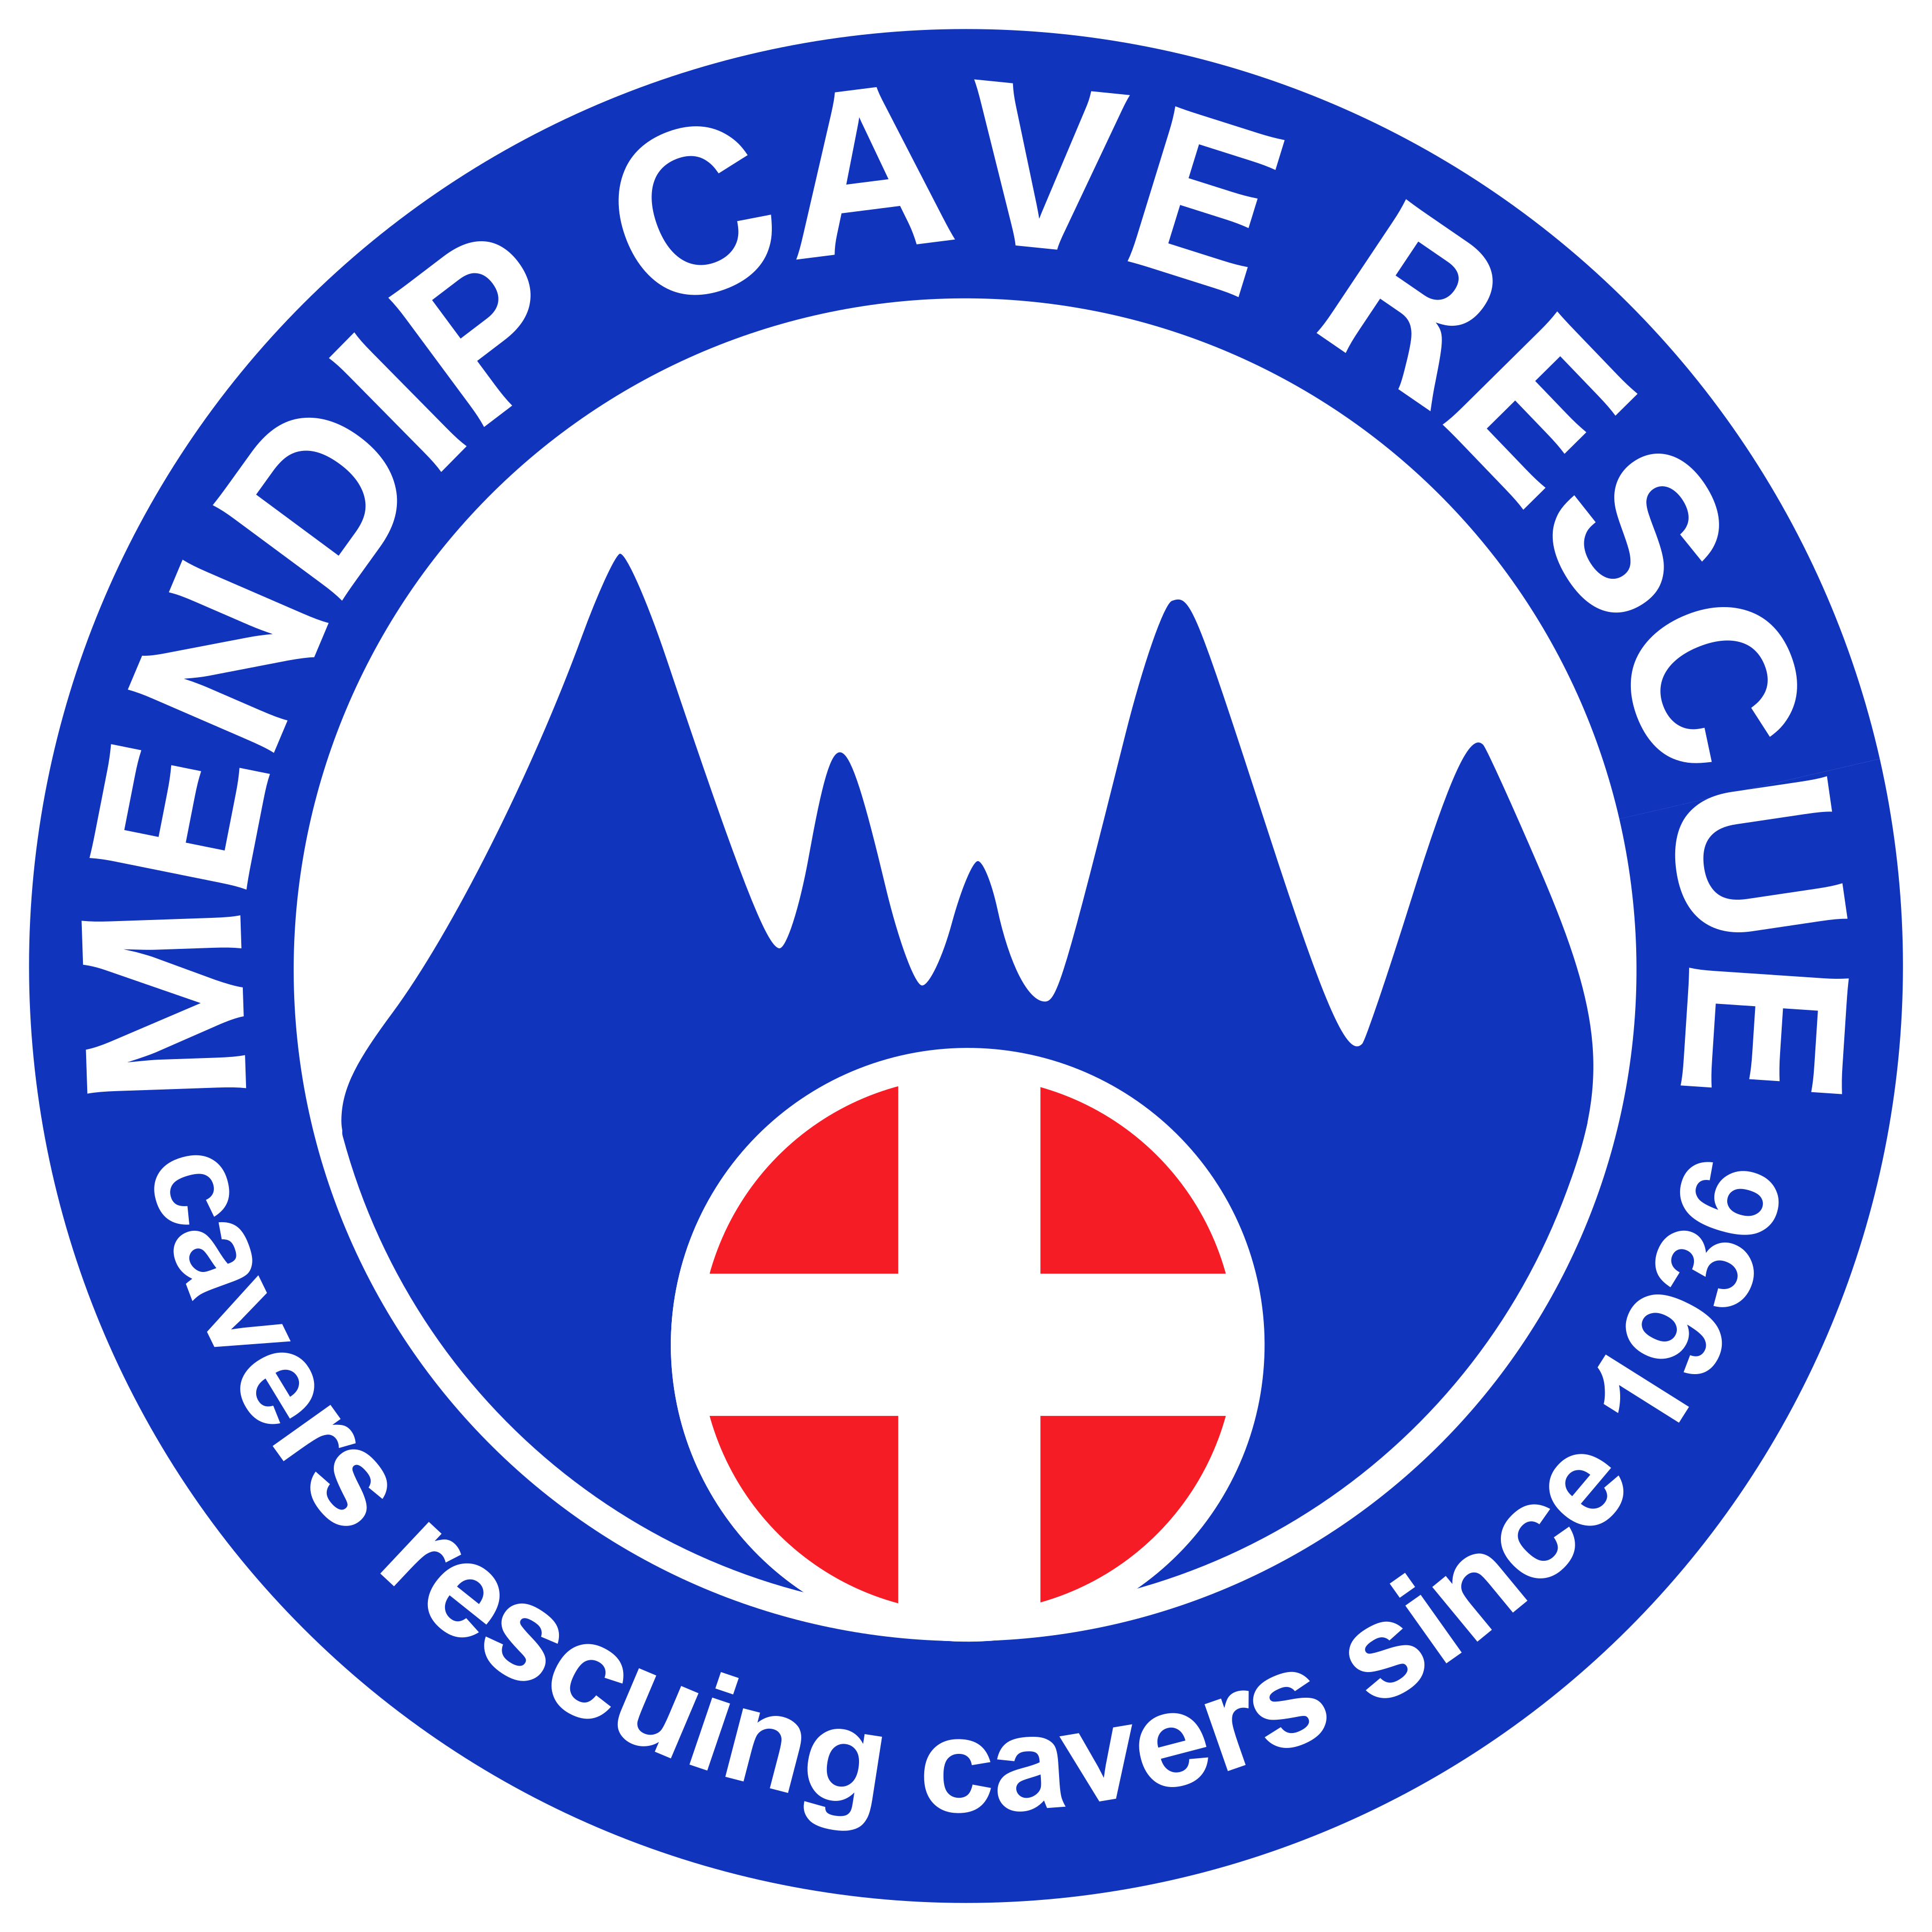 | Mendip Cave Rescue  Application for Membership  Sponsors Form

Introduction

Membership of Mendip Cave Rescue is now open to all cavers active in MCR's area of cover. Before a new member can be allowed to go underground on training / incidents with MCR, we must be sure that they have the relevant caving skills which include self-sufficiency in looking after themselves underground and be competent with personal progression through various caves. They must also be fit enough to tackle a variety of cave systems within MCR's region and have an awareness of maintaining their own personal caving equipment.

To help assess an applicant's suitability to join MCR, please complete this sponsors form to confirm that they meet the membership criteria and return it to the Membership Secretary.

Successful applicants for Core membership will spend a minimum of 12 months (up to a maximum of 24 months) as a Provisional Member, during which time they will be assigned a mentor to guide them through the induction process, help facilitate any training required and introduce them to other MCR members. By default, the applicants sponsor will be appointed as their mentor but if you feel that an alternative MCR member would be better suited to the mentor role for this applicant please discuss this with them, and indicate the proposed mentor in the section below.

Personal Details

Sponsors name
Contact phone number
Email address
Applicants name
Brief description of your caving experience with the applicant
Application

I confirm that the applicant meets the following criteria from the person specification contained on the MCR membership application form:

Over 18 years old and has at least two years of caving experience | Y / N
Active & available in MCR's area of operation for the foreseeable future | Y / N
Current member of the British Caving Association, or affiliated caving club | Y / N
Able to commit to MCR's training requirements | Y / N
Would be a good team player within MCR | Y / N
Will give service freely & voluntarily, and to the best of my knowledge is not applying to join MCR for any vested personal or commercial gain | Y / N
For underground roles, fit enough to tackle a variety of caves in MCR's region | Y / N
For underground roles, has demonstrated competency in ladder and SRT skills and the ability to tie a variety of knots | Y / N
For core member applications, I confirm that the following MCR member has agreed to act as a mentor to help guide them through their MCR induction  Mentors name | Y / N
I confirm that all the information I have provided is accurate and that I have no conflict of interest associated with this membership application | Y / N
Signature: | Date:

membership@mendipcaverescue.org https://www.mendipcaverescue.org

